# ABC’s Inventory Management System

## Test Script

|  |  |  |  |  |  |
| --- | --- | --- | --- | --- | --- |
| **Test Name** | | Accept The New Products In Current Location (Test Case APT003) | | | |
| **Use Case Tested** | | Accept Product | | | |
| **Test Description** | | This test tests if the system can accept transfer that sending the products what have not been recorded its information in current destination. | | | |
| **Pre-Conditions** | | Product Item Code, Sending Location ID, Destination Location ID, Product Quantity, Description, date, status, transferID | | | |
| **Post-Conditions** | | Accepted Products should be added to the current location, the status of transfer change to “Accepted”, the accepted transfer should be removed from the accept transfer table, the new products information should be added to the current location, the quantity of accepted products should be changed appropriately. | | | |
| **Notes** | | This test assumes that the user knows the transferID. | | | |
| **Result (Pass/Fail/Warning/ Incomplete)** | | Pass | | | |
|  | **Test Step** | | **Expected Test Results** | **P** | **F** |
| 1. | Select Accept Product Button from home page | | Display the Accept Product page |  |  |
| 2. | Input transfer ID in search field and click on the Search Button | | System display correct searched transfer | P |  |
| 3. | Click on the “View Product in this Transfer” button to check the sending products detail for accepting | | System displays a list of sending products and its quantity | P |  |
| 4. | Click on the “Accept” Button | | Accepted Products should be added to the current location, the status of transfer change to “Accepted”, the accepted transfer should be removed from the accept transfer table, the new products information should be added to the current location, the quantity of accepted products should be changed appropriately. | P |  |

## Data Set 1

|  |  |
| --- | --- |
| **Test Data Table** | |
| **transferID** | 53 |
| **Destination** | Warehouse |

# Result Screenshots

The screenshots of the result on each test step for each data set are given below:

**Step 1**

Open the Accept Product Page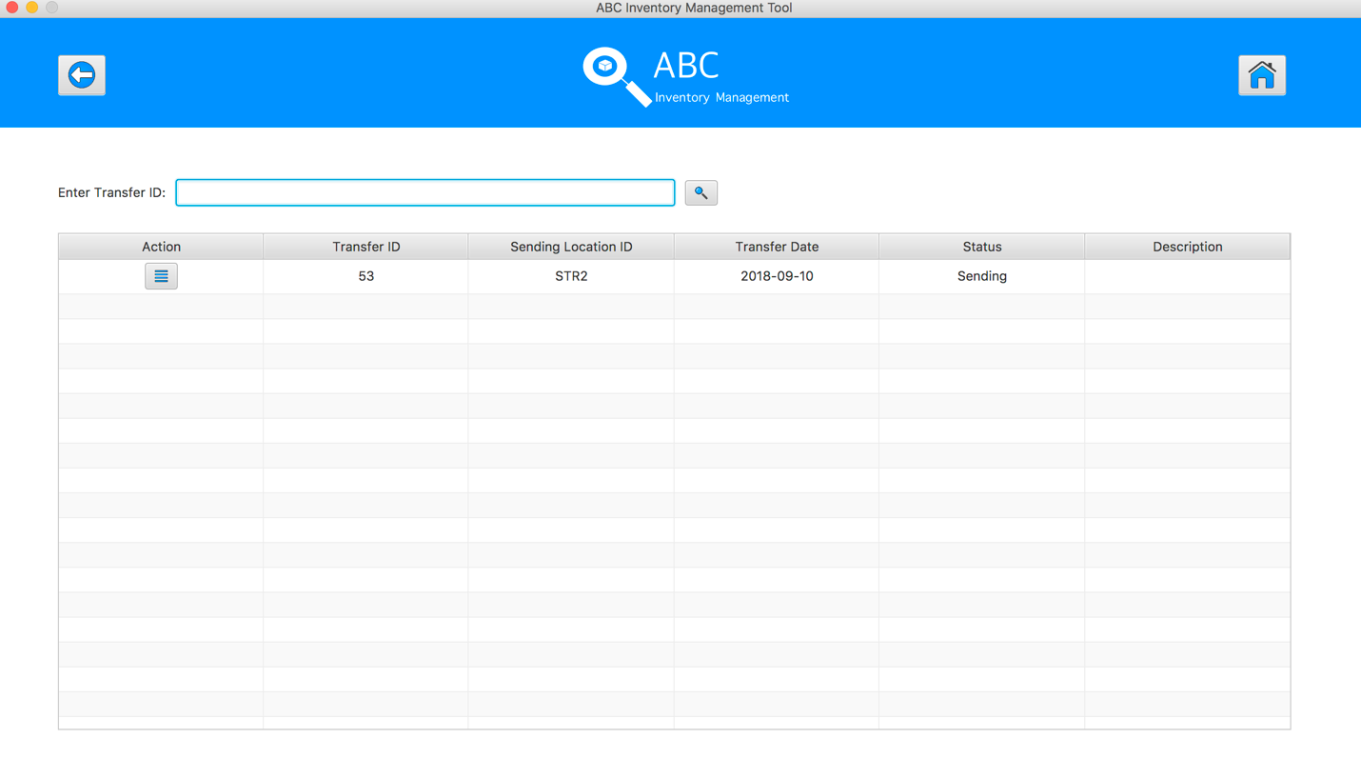

**Step 2**

Click on the “View Product in this Transfer” button of transfer ID = 52, the system displays the sending products detail for accepting 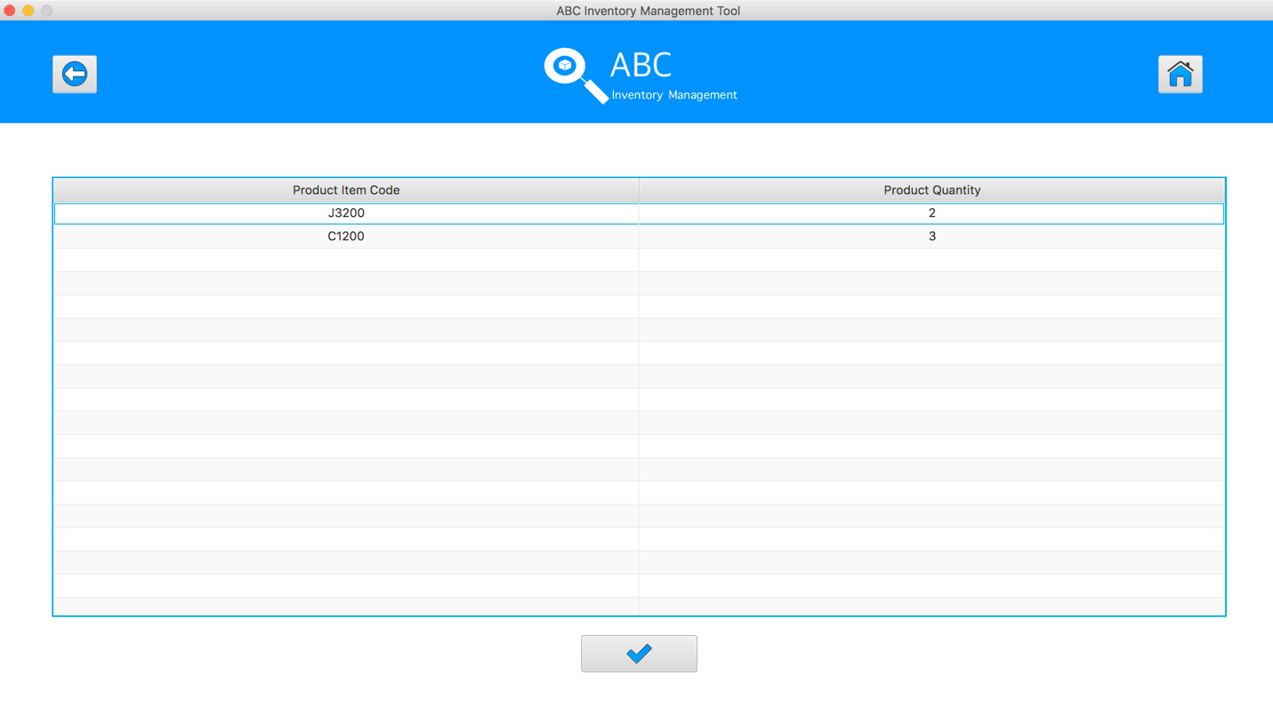

**Step 3**

Click on the “Accept” Button 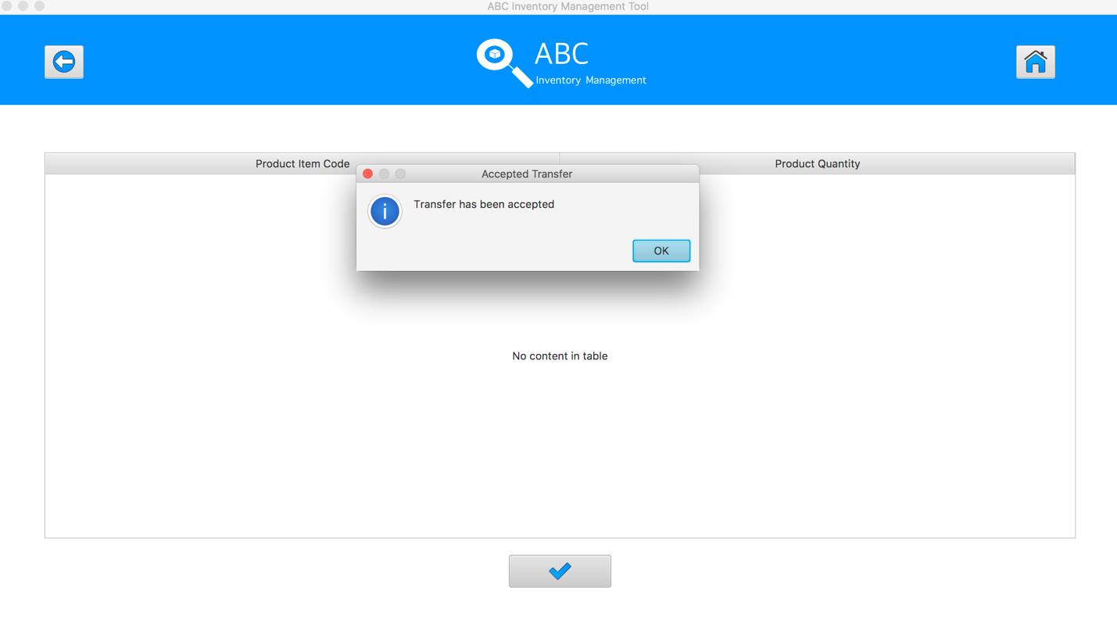

The quantity of accepted product will be changed appropriately.

|  |  |
| --- | --- |
| Before | After |
|  |  |

## Data Set 2

|  |  |
| --- | --- |
| **Test Data Table** | |
| **transferID** | 44 |
| **Destination** | Epping Store |

# Result Screenshots

The screenshots of the result on each test step for each data set are given below:

**Step 1**

Open the Accept Product Page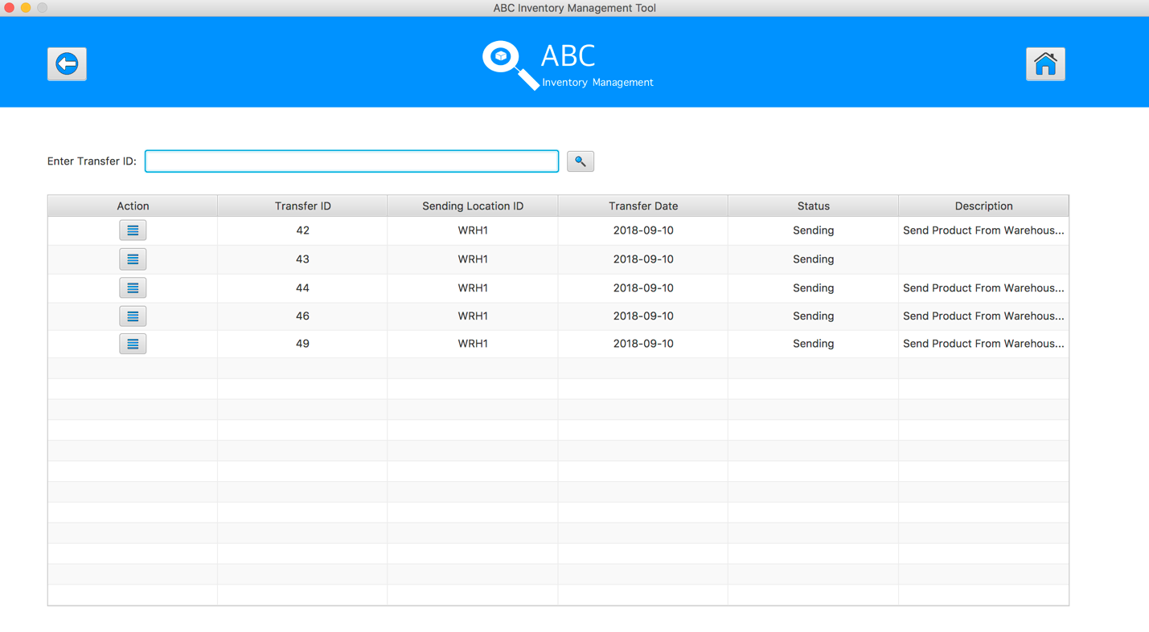

**Step 2**

Input transfer ID in search field and click on the Search Button

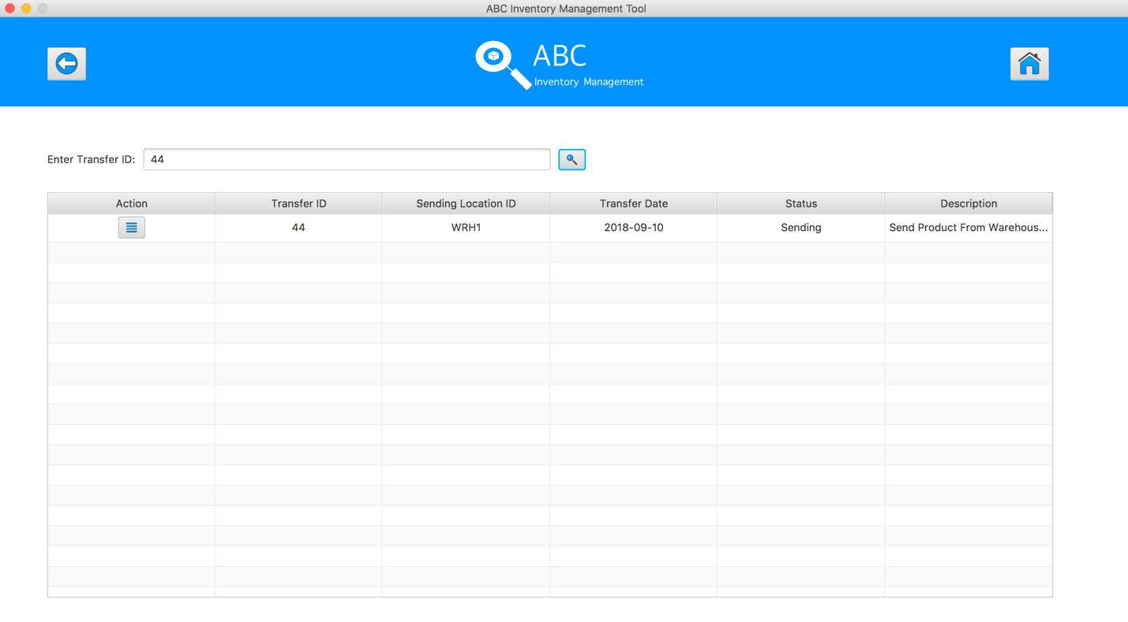

**Step 3**

Click on the “View Product in this Transfer” button, the system displays the sending products detail for accepting 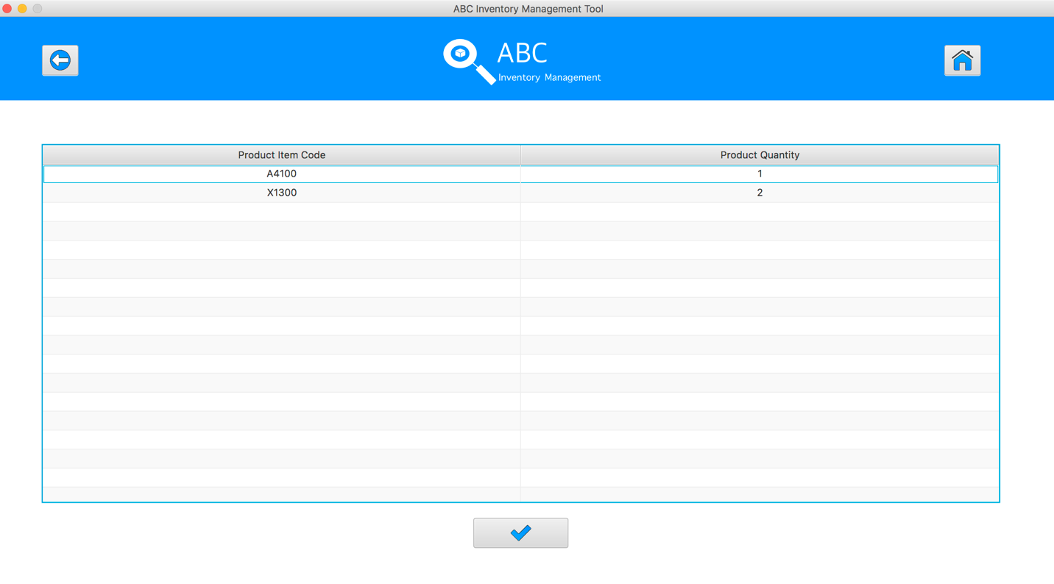

**Step 4**

Click on the “Accept” Button 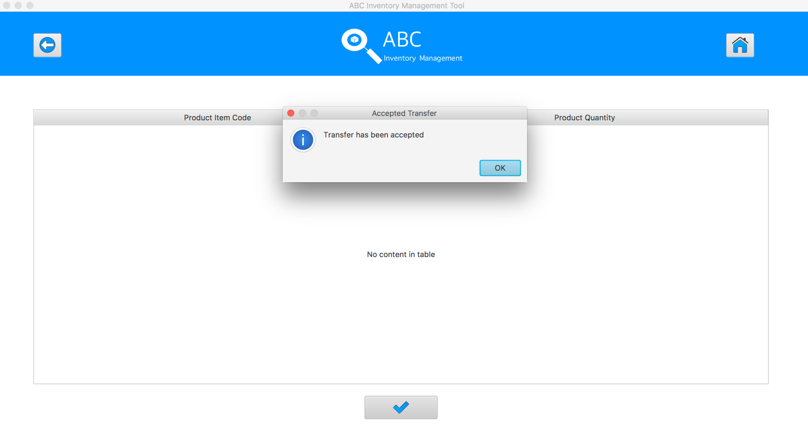

The quantity of accepted product will be changed appropriately.

|  |  |
| --- | --- |
| Before | After |
|  |  |

## Data Set 3

|  |  |
| --- | --- |
| **Test Data Table** | |
| **transferID** | 50 |
| **Destination** | Warehouse |

# Result Screenshots

The screenshots of the result on each test step for each data set are given below:

**Step 1**

Open the Accept Product Page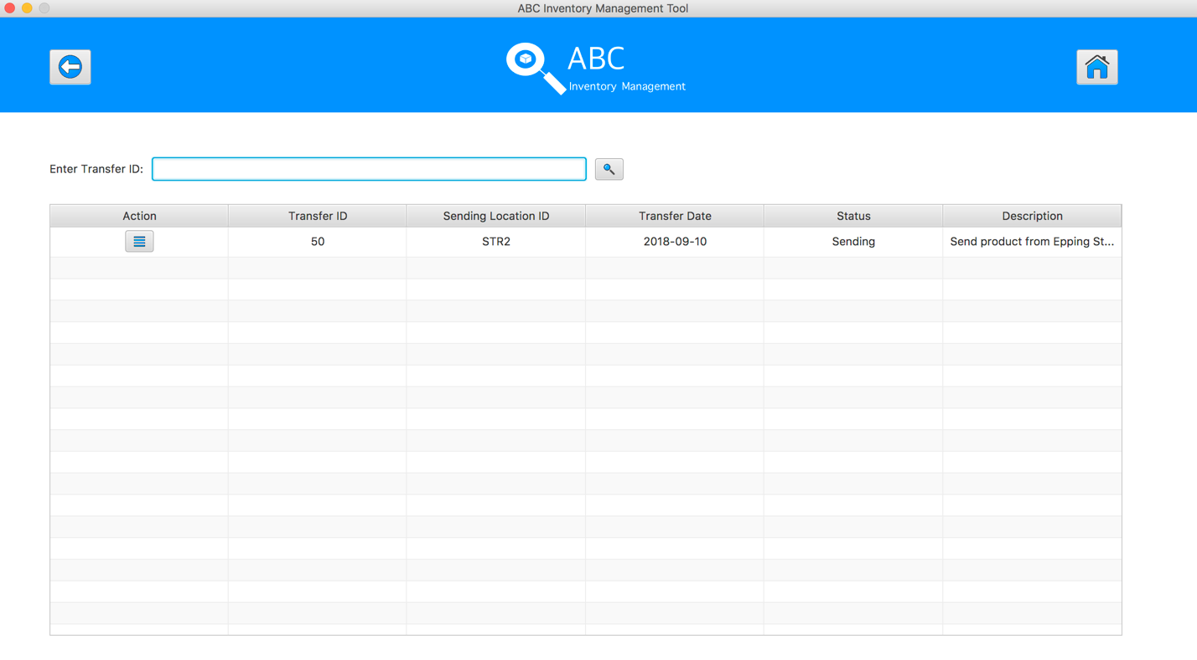

**Step 2**

Input transfer ID in search field and click on the Search Button

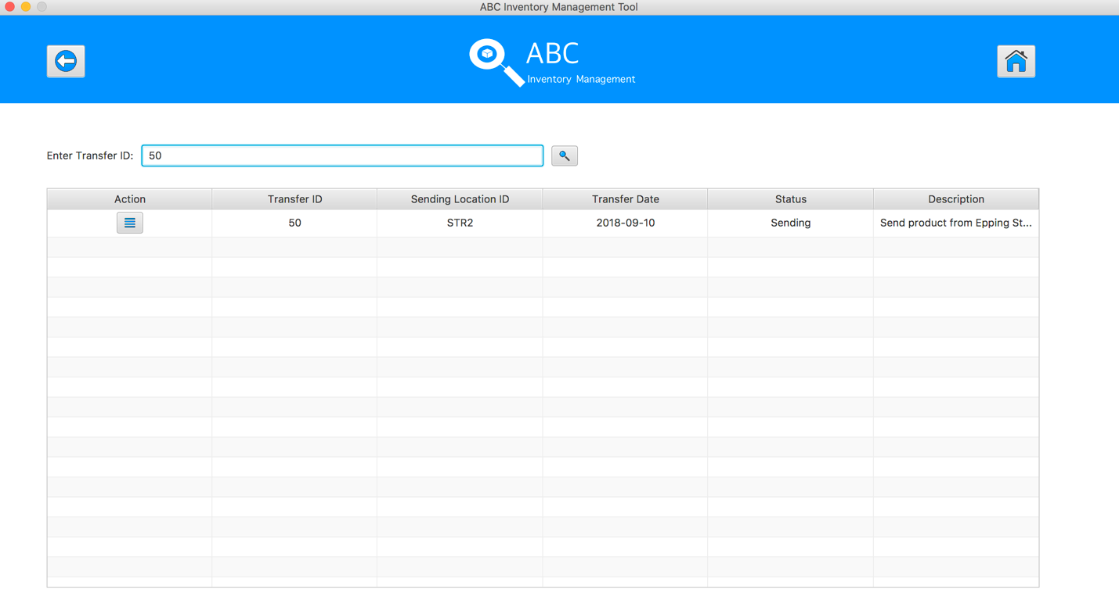

**Step 3**

Click on the “View Product in this Transfer” button, the system displays the sending products detail for accepting 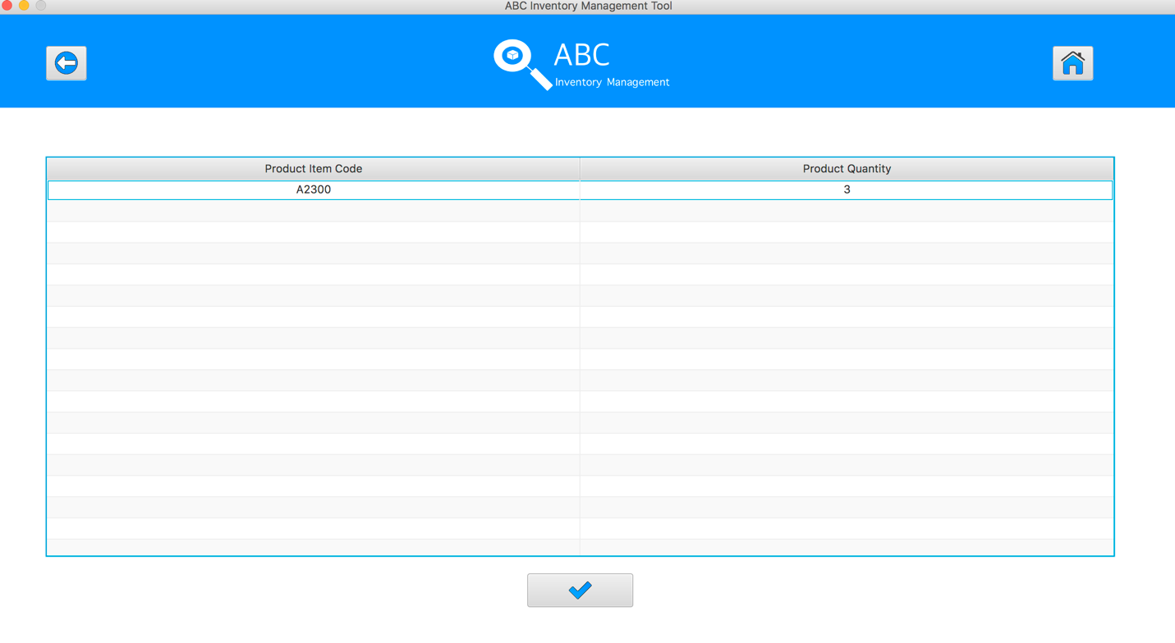

**Step 4**

Click on the “Accept” Button 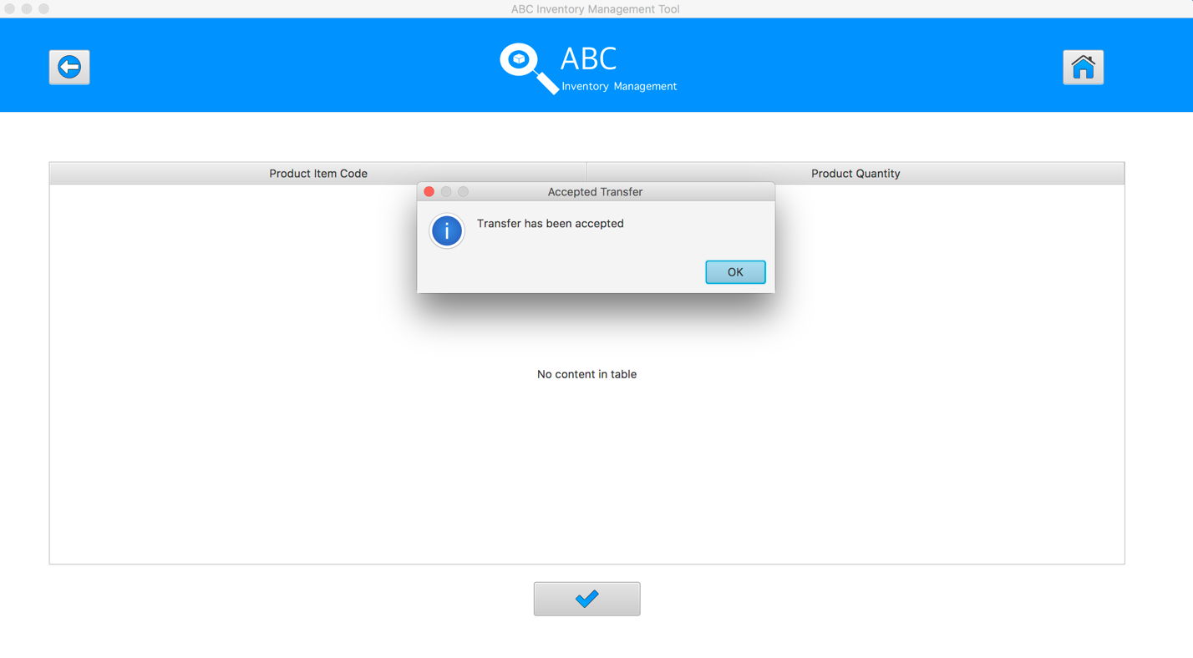

The quantity of accepted product will be changed appropriately.

|  |  |
| --- | --- |
| Before | After |
|  |  |